***Challenge* 02**

**1.Write a bash script to find the latency from the sample nginx log file.**

**Bash script should only only print the latency.**

**--Send the log_test.csv file from windows to linux**

**--Bash Script**

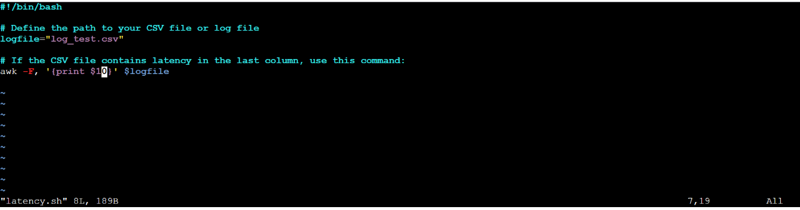

**--run the script**

**--Output: print the value of the 10th field in each line of the file**

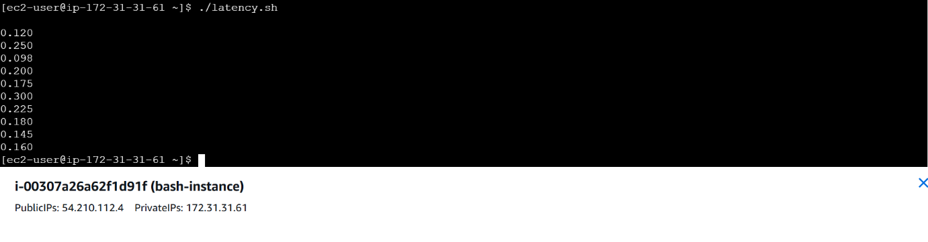

**2.Bash Script to create repo in github.**

**--bash script**

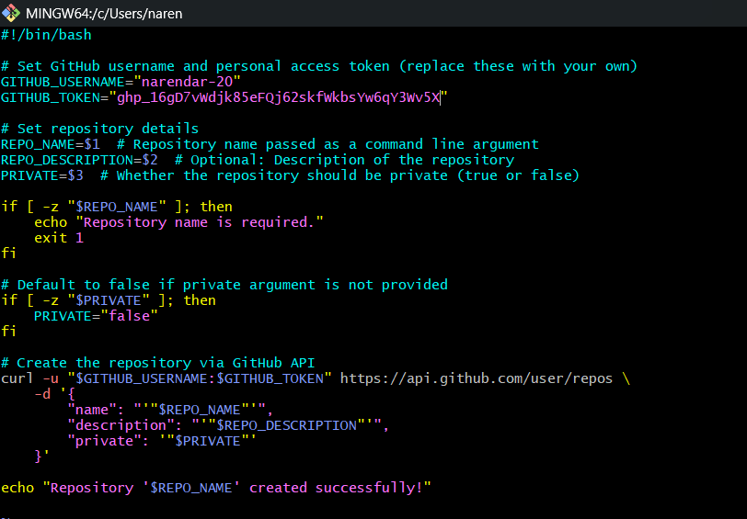

**--run the script**

**--New test repo created in git bash**

